Lab 05: Polymorphism
Student Name: Jichichi Clive T
Registration Number: H250254B
Programme: Software Engineering
Date: 10/10/2026
Exercise 1: Method Overloading
Aim: To demonstrate method overloading by creating multiple methods with the same name but different parameter types.
Source Code
PrintDemo.java

package lab05polymorphism;

import java.util.Arrays;

// Demonstrates method overloading
public class PrintDemo {

// Accepts an integer
public void print(int number) {
System.out.println("Integer: " + number);
}

// Accepts a decimal number
public void print(double number) {
System.out.println("Double: " + number);
}

// Accepts a string
public void print(String text) {
System.out.println("String: " + text);
}

// Accepts an array of integers
public void print(int[] numbers) {
System.out.println(
"Integer array: " + Arrays.toString(numbers));
}
}
Main.java

package lab05polymorphism;

// Tests the overloaded print methods
public class Main {

public static void main(String[] args) {

PrintDemo demo = new PrintDemo();

demo.print(25);
demo.print(12.5);
demo.print("Java OOP");
demo.print(new int[]{10, 20, 30});
}
}
Output
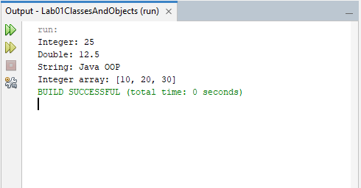
Explanation: The PrintDemo class contains four overloaded print() methods that accept an integer, a double, a string, and an integer array. Java selects the appropriate method based on the argument supplied in each call. Arrays.toString() displays the array elements in a readable format.
Conclusion: The exercise demonstrates compile-time polymorphism through method overloading.

Exercise 2: Runtime Polymorphism
Aim: To demonstrate runtime polymorphism using an Animal parent class and three subclasses.
Source Code
Animal.java

package lab05polymorphism;

// Parent class for different animals
public class Animal {

public void sound() {
System.out.println("Animal makes a sound.");
}
}
Cat.java

package lab05polymorphism;

// Cat inherits from Animal
public class Cat extends Animal {

@Override
public void sound() {
System.out.println("Cat says: Meow!");
}
}
Cow.java

package lab05polymorphism;

// Cow inherits from Animal
public class Cow extends Animal {

@Override
public void sound() {
System.out.println("Cow says: Moo!");
}
}
Duck.java

package lab05polymorphism;

// Duck inherits from Animal
public class Duck extends Animal {

@Override
public void sound() {
System.out.println("Duck says: Quack!");
}
}
Main.java

package lab05polymorphism;

// Demonstrates runtime polymorphism using an array
public class Main {

public static void main(String[] args) {

Animal[] animals = {
new Cat(),
new Cow(),
new Duck()
};

// Each object uses its own overridden sound() method
for (Animal animal : animals) {
animal.sound();
}
}
}
Output
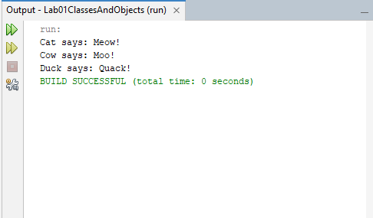
Explanation: Cat, Cow, and Duck extend Animal and override its sound() method. The objects are stored in an Animal[] array. When the loop calls animal.sound(), Java executes the method belonging to the actual object.
Conclusion: The exercise demonstrates inheritance, method overriding, and runtime polymorphism while allowing different animal objects to be handled through a common parent type.

Exercise 3: Polymorphic Employee Payroll
Aim: To extend an employee hierarchy with an intern and calculate payroll using runtime polymorphism.
Source Code
Employee.java

package lab05polymorphism;

// Parent class for all employees
public abstract class Employee {

protected String name;

public Employee(String name) {
this.name = name;
}

public String getName() {
return name;
}

// Subclasses must calculate their own pay
public abstract double calculatePay();
}
FullTimeEmployee.java

package lab05polymorphism;

// Employee who receives a fixed monthly salary
public class FullTimeEmployee extends Employee {

private double monthlySalary;

public FullTimeEmployee(String name, double monthlySalary) {
super(name);
this.monthlySalary = monthlySalary;
}

@Override
public double calculatePay() {
return monthlySalary;
}
}
PartTimeEmployee.java

package lab05polymorphism;

// Employee paid according to hours worked
public class PartTimeEmployee extends Employee {

private double hoursWorked;
private double hourlyRate;

public PartTimeEmployee(
String name, double hoursWorked, double hourlyRate) {
super(name);
this.hoursWorked = hoursWorked;
this.hourlyRate = hourlyRate;
}

@Override
public double calculatePay() {
return hoursWorked * hourlyRate;
}
}
Intern.java

package lab05polymorphism;

// Intern receives a fixed stipend
public class Intern extends Employee {

private double stipend;

public Intern(String name, double stipend) {
super(name);
this.stipend = stipend;
}

@Override
public double calculatePay() {
return stipend;
}
}
Main.java

package lab05polymorphism;

// Demonstrates payroll calculation using polymorphism
public class Main {

public static void main(String[] args) {

Employee[] employees = {
new FullTimeEmployee("Tendai", 1500.00),
new PartTimeEmployee("Rudo", 40, 10.00),
new Intern("Kuda", 300.00)
};

double totalPayroll = 0;

// The loop works with every Employee subclass
for (Employee employee : employees) {
double pay = employee.calculatePay();

System.out.printf("%s: $%.2f%n",
employee.getName(), pay);

totalPayroll += pay;
}

System.out.printf("Total payroll: $%.2f%n",
totalPayroll);
}
}
Output
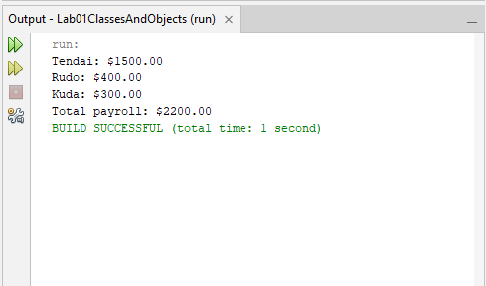
Explanation: The abstract Employee class defines a common calculatePay() method. FullTimeEmployee, PartTimeEmployee, and Intern implement this method according to their payment arrangements. A mixed Employee[] array stores all three types. The payroll loop calls the same method for every employee without checking their individual classes.
Conclusion: The exercise demonstrates how polymorphism improves code reuse and allows new employee types to be added without modifying the payroll loop.

Exercise 4: Field Hiding and Method Overriding
Aim: To demonstrate the difference between accessing fields and calling overridden methods through a superclass reference.
Source Code
Parent.java

package lab05polymorphism;

// Parent class
public class Parent {

public String message = "Parent field";

public void display() {
System.out.println("Parent method");
}
}
Child.java

package lab05polymorphism;

// Child class hides the parent's field and overrides its method
public class Child extends Parent {

public String message = "Child field";

@Override
public void display() {
System.out.println("Child method");
}
}
Main.java

package lab05polymorphism;

// Demonstrates field hiding and method overriding
public class Main {

public static void main(String[] args) {

Parent object = new Child();

// Field access depends on the reference type
System.out.println(object.message);

// Method call depends on the actual object's type
object.display();
}
}
Output
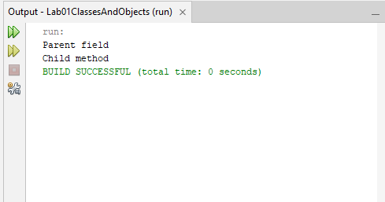
Explanation: The Parent class defines a field called message and a method called display(). The Child class declares a field with the same name and overrides the method. When a Parent reference points to a Child object, accessing object.message displays the parent field because field access is determined by the reference type. Calling object.display() executes the child method because overridden instance methods use runtime polymorphism.
Conclusion: The exercise demonstrates that field hiding and method overriding behave differently in Java.

Exercise 5: Payment Processing
Aim: To compare type checking using instanceof pattern matching with runtime polymorphism.
Source Code
Payment.java

package lab05polymorphism;

// Parent class for payment types
public abstract class Payment {
public abstract void process();
protected double amount;

public Payment(double amount) {
if (amount <= 0) {
throw new IllegalArgumentException(
"Payment amount must be greater than zero.");
}

this.amount = amount;
}
}
CardPayment.java

package lab05polymorphism;

// Represents a card payment
public class CardPayment extends Payment {

private String cardNumber;

public CardPayment(double amount, String cardNumber) {
super(amount);
this.cardNumber = cardNumber;
}
@Override
public void process() {
System.out.printf(
"Card payment of $%.2f processed using card ending %s.%n",
amount,
cardNumber.substring(cardNumber.length() - 4));
}
}
MobileMoneyPayment.java

package lab05polymorphism;

// Represents a mobile money payment
public class MobileMoneyPayment extends Payment {

private String phoneNumber;

public MobileMoneyPayment(double amount, String phoneNumber) {
super(amount);
this.phoneNumber = phoneNumber;
}
@Override
public void process() {
System.out.printf(
"Mobile money payment of $%.2f processed for %s.%n",
amount, phoneNumber);
}
}
PaymentProcessor.java

package lab05polymorphism;

// Processes payments by checking their concrete types
public class PaymentProcessor {

public void pay(Payment payment) {

if (payment instanceof CardPayment card) {
card.process();

} else if (payment instanceof MobileMoneyPayment mobile) {
mobile.process();

} else {
throw new IllegalArgumentException(
"Unsupported payment type.");
}
}
}
PolymorphicPaymentProcessor.java

package lab05polymorphism;

// Processes payments using runtime polymorphism
public class PolymorphicPaymentProcessor {

public void pay(Payment payment) {
payment.process();
}
}
Main.java

package lab05polymorphism;

// Compares instanceof and polymorphic payment processing
public class Main {

public static void main(String[] args) {

Payment[] payments = {
new CardPayment(50.00, "1234567812345678"),
new MobileMoneyPayment(25.00, "+263771234567")
};

System.out.println("DESIGN 1: INSTANCEOF");

PaymentProcessor processor = new PaymentProcessor();

for (Payment payment : payments) {
processor.pay(payment);
}

System.out.println();
System.out.println("DESIGN 2: POLYMORPHISM");

PolymorphicPaymentProcessor polymorphicProcessor =
new PolymorphicPaymentProcessor();

for (Payment payment : payments) {
polymorphicProcessor.pay(payment);
}
}
}
Output
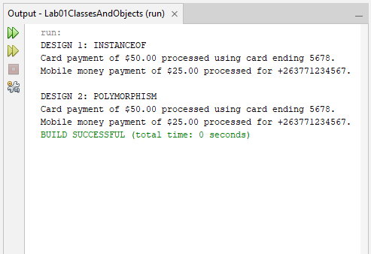
Explanation: The first PaymentProcessor checks whether the payment is a CardPayment or MobileMoneyPayment and then calls the relevant method. The refactored design declares an abstract process() method in Payment and overrides it in each payment subclass. The polymorphic processor calls payment.process() without checking the concrete type.
Comparison: The instanceof design explicitly identifies payment types and requires additional branches when new types are introduced. The polymorphic design allows new payment types to provide their own processing behaviour without modifying the processor.
Conclusion: Both designs process the example payments, but polymorphism provides a more extensible design by reducing type-specific checks.

